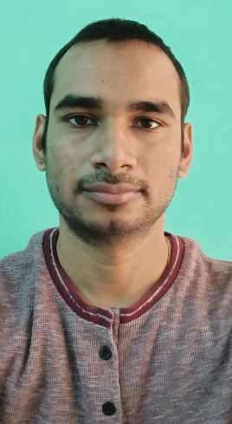BIO-DATA

Name: Dr. Surendra Verma

Date of Birth: 25-01-1993

Education: B.Tech, M.Tech, Ph.D in Aerospace Engineering, IIT Kharagpur, West-Bengal, India

(July 10 – Dec 21)

Work experience: Assistant Professor for one semester contract in Punjab Engineering College, Chandigarh

(July 22 – 31 Nov 22)

Post- Doctoral in Mechanical Engineering, Ryerson University, Toronto, Canada

(1 Dec - Present)

Height: 165cm or 5’4’’

Color: Fair

Father’s Name: Suraj Ram

Father’s Job: Income Tax officer (ITO), Gwalior

Mother’s Name: Ram Kumari

Mother’s Job: Home Maker

Brother and Sister: Chandra Shekhar Arya (B.E, Married)

Archana Arya Verma (B.Sc and B.Ed, Married)

Residential Address: 1153, Babulal Ka Bagicha, Khusipura, Jhansi (UP)

Contact Number: +91 6266739918 (Father)

Native Place: Village Bansar, Post Bijna (Jhansi)

Father’ Gotra: Kargainya

Mother’s Gotra: Garouthiya